INTRODUCTION

In November 2022 the Wellcome Trust, a large UK based research charity organisation, published a two part series called ‘What science has shown can help young people with anxiety and depression: identifying and reviewing the 'active ingredients' of effective interventions’[1]. The aim of the report was to select and report on a number of interventions currently available to help with young people’s symptoms of anxiety and depression. Specifically, the researchers at Wellcome wanted to help identify interventions that had clearly defined ‘active ingredients’, which are the aspects of an intervention which actually help with making change.

When the report was commissioned in 2020, Wellcome invited research teams from across the world to review the evidence for these different active ingredients. This resulted in over 50 research teams being assigned to review 46 active ingredients. The active ingredients were broadly categorised by their focus of change into six groups: (i) behaviours and activities; (ii) beliefs and knowledge; (iii) brain/body functions; (iv) cognitive and attentional skills; (v) human connections; and (vi) socioeconomic factors (see table below).

Each research team was tasked with examining whether or not the existing evidence showed that their active ingredient is effective among 14 to 24-year-olds, including whether there are subgroups or contexts in which their ingredient is particularly effective or ineffective, and the potential mechanisms of action underpinning the effect of their active ingredient. In short, they were asked to address the question: ‘What works, for whom, in what contexts, and why?’ In addition, teams were asked to involve young people, ideally with lived experience of anxiety and/or depression, as part of their review process, with the aim of ensuring a grounded and holistic approach.

ICAMH will embark on a new series over the coming months where, in the interest of scientific dissemination and communication, we will provide a brief breakdown of the evidence found for each active ingredient.
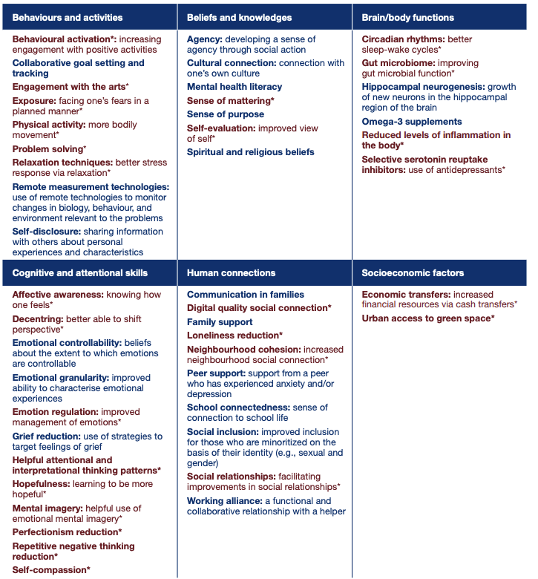

References
1. Wellcome. Report summary: What science has shown can help young people with anxiety and depression. 2022; Available from: https://wellcome.org/reports/what-science-has-shown-can-help-young-people-anxiety-and-depression.

